**Artificial neural network**:

This Article/Blog is to make the person who is reading this to make them understand what are Artificial neural networks, and to make them know about the benefits about ANN’s.

Section will be divided into certain chapters for better readability and a better understanding.

Chapter 1: Introduction.

Chapter 2:Applications and usage.

Chapter 3: In depth Analysis of an Ann

Chapter 4 : build your first Ann and challenges that I faced while building mine.

Chapter 5: Summary.

**INTRODUCTION:**

Well, We have arrived to our first chapter . Buckle up its going to be one crazy and fun ride. Now let us understand what is a neural network first , so a neural network is the reason that humans differ from normal animals . Neural networks give us the ability to reason, think and adapt . so what does this neural network contain you might ask ? . It Contains the most important part of any network .. Nodes in our case they are called as **NEURONS.** Neurons are the basic building blocks of our brain . they are the key to our amazing abilities. Do you want to know how an actual Neuron looks of a brain cell . Here you go take a sneak peek.

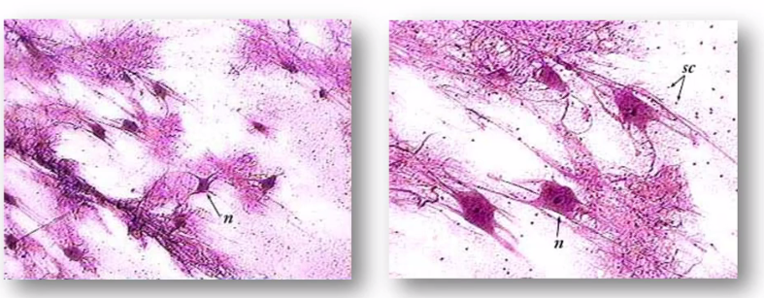

Fig 1.a

The above figure is a picture of a actual neuron from a brain smeared to glass and freezed and looked from a microscope.

So what do neurons do ?

To know them let us look at a pictorial representation of a neural network.

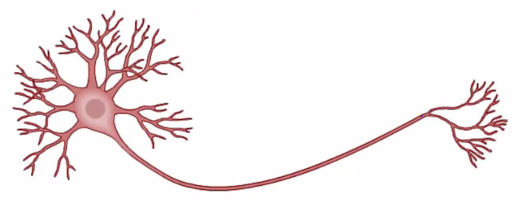

Fig 1.b

So as you can see a typical neuron contains an head and tail . And each head and tail contains some branches. Now talking more “scientifically” the head of the neuron is known as “neuron” itself. And the branches coming out of the head are known as “dendrites” and the long tail is known as an “ Axon”. Now a single neuron is pretty much useless but millions and trillions of neurons together in a networks working together that’s makes use ..Yay!!!.They pass electrical impulses between them and make us who we are .

Now enough about the biology part . I never liked the subject anyway . Lets talk about what is an Artificial neural network. An ANN as the name tells is and in layman terms is an artificial version of the huge network that is in our brain. It tries to replicate our brains functionality well at least some of its functionalities like the ability to adapt and think on its own as time progresses. So why do we want a an Artificial neural network . Well to answer that question . I would also ask two more counter questions . well why do we want computers or why do we want smart phones ? . Its to make our lives easier . but there’s a catch A smart phone is actually not as smart as you think simply because it was pre programmed to do certain stuff and it can be preprogrammed to do even more things but it cannot think and adapt like a human can it?

So what if we give machines the ability to Think and learn by themselves . Well then even they can be as useful as us or even more capable then us . I understand your concern that if we give machines the ability to think and learn wont they surpass us and dominate us . Well that’s the concept of “Doomsday” as termed by Elon musk . But guys don’t worry currently the most intelligent computer as an IQ of a “Cockroach” So there wont be any doomsday in our near future. But the benefits of making machines learn are many like I am not even kidding . Let us look at some of the benefits in our next chapter.